TC-CSC-001
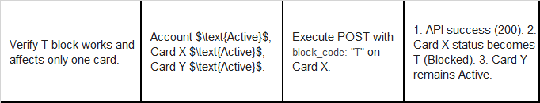
Card Before Block Code Set
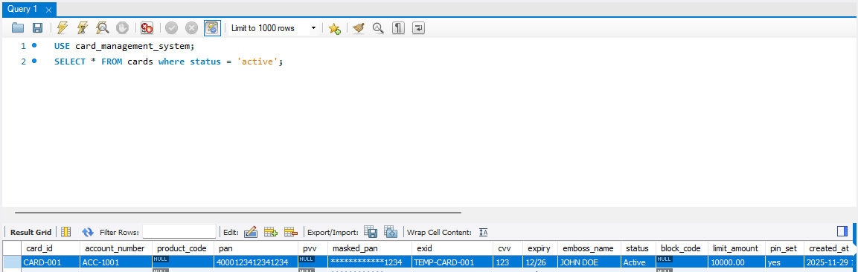
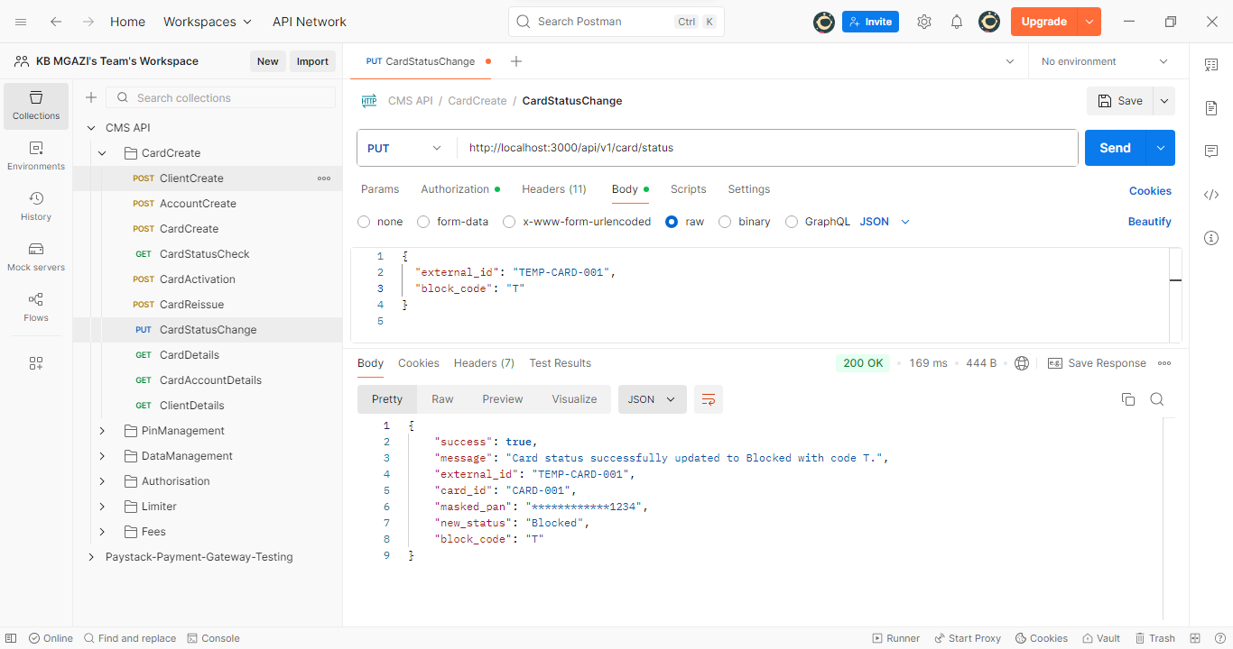
Request:
{
"external_id": "TEMP-CARD-001",
"block_code": "T"
}

Response:
{
"success": true,
"message": "Card status successfully updated to Blocked with code T.",
"external_id": "TEMP-CARD-001",
"card_id": "CARD-001",
"masked_pan": "************1234",
"new_status": "Blocked",
"block_code": "T"
}

